1) Provided options for choosing Course Career, Semester and Career Option

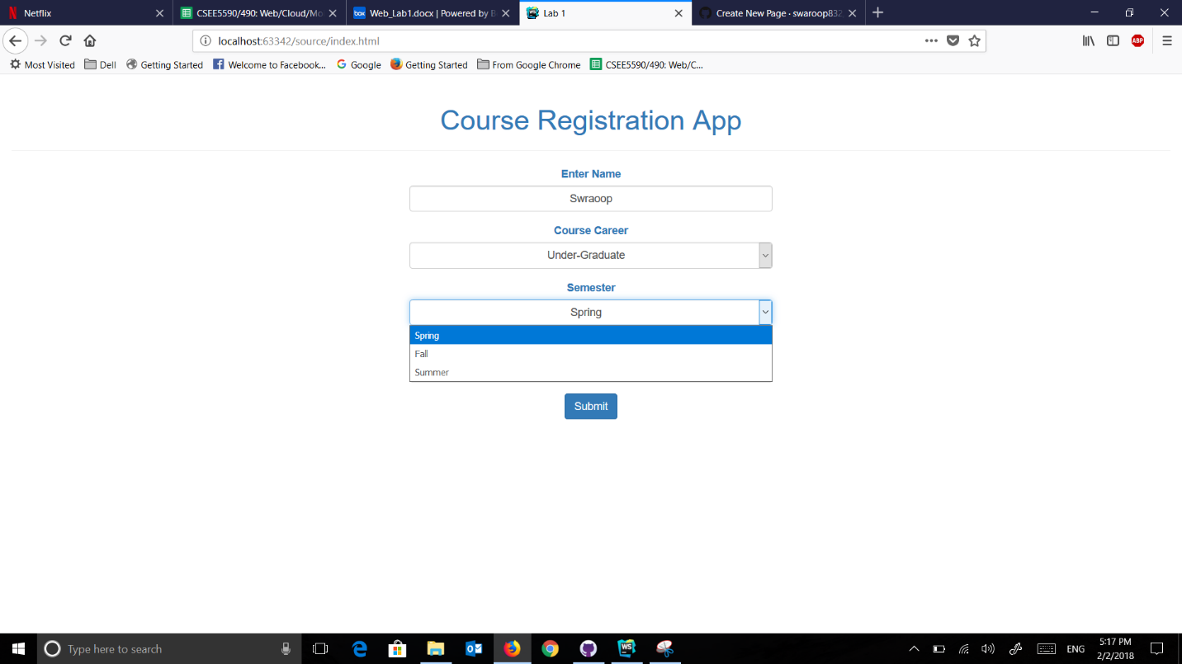

2) Selected Course Career as Graduate, Fall semester for LAW

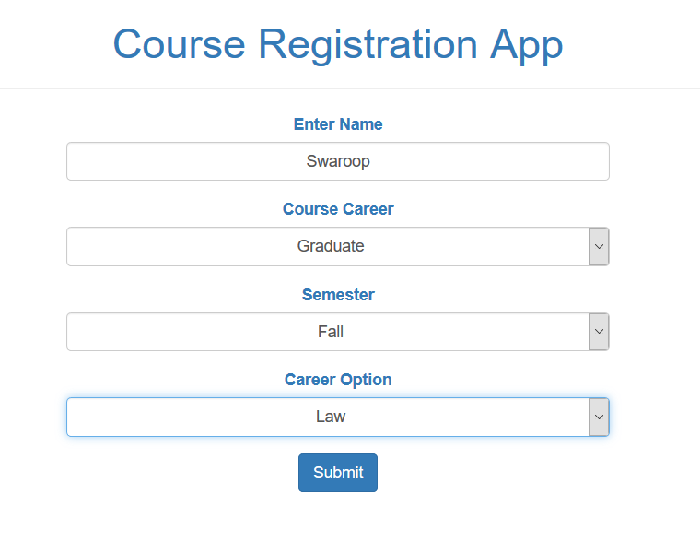

3) After Pressing submit, it shows the search results

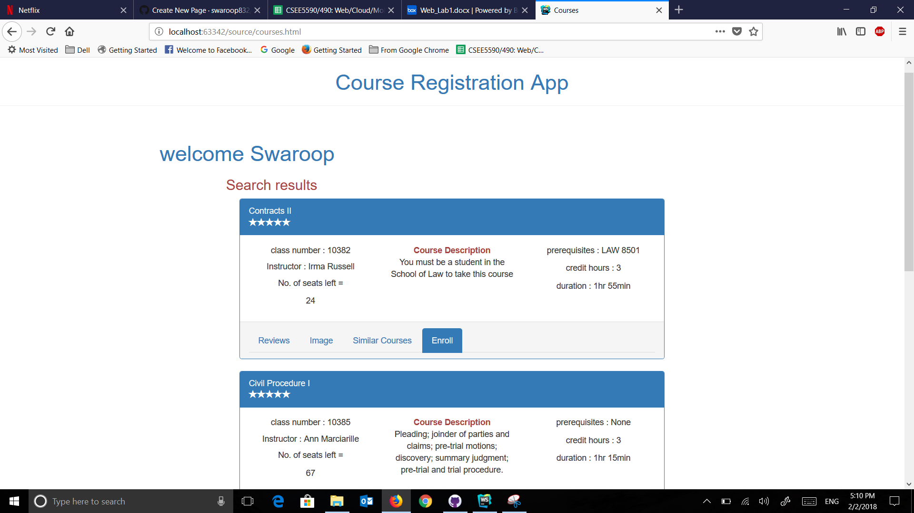

4) Every Course is provided with relevant information such as instructor name, course description, prerequisites, credit hours, etc.

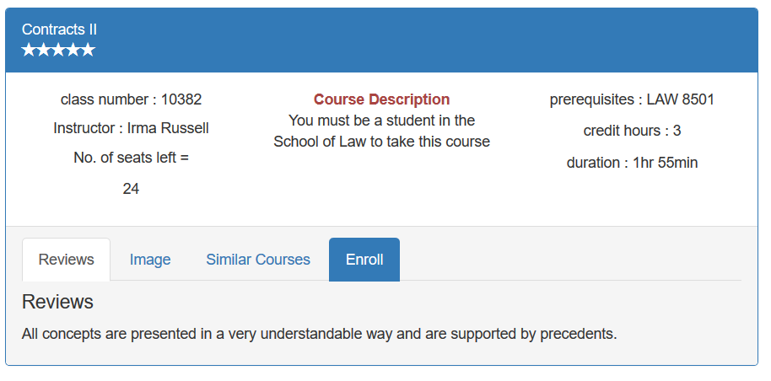

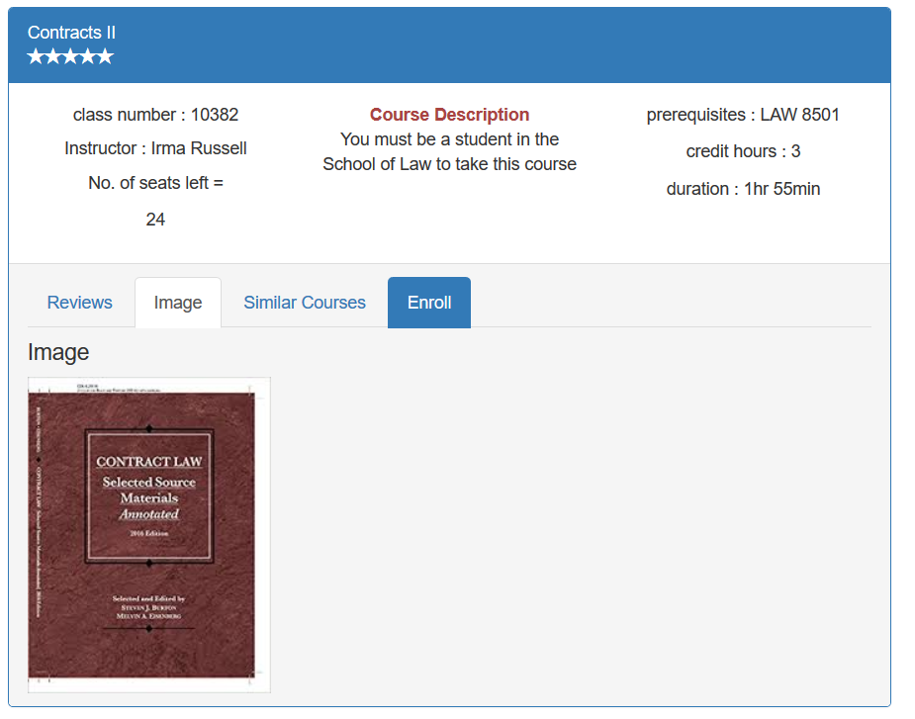

5) Selecting the course which we want to enroll by ENROLL button at each course.

Selected contracts 2 course which has 24 seats left.

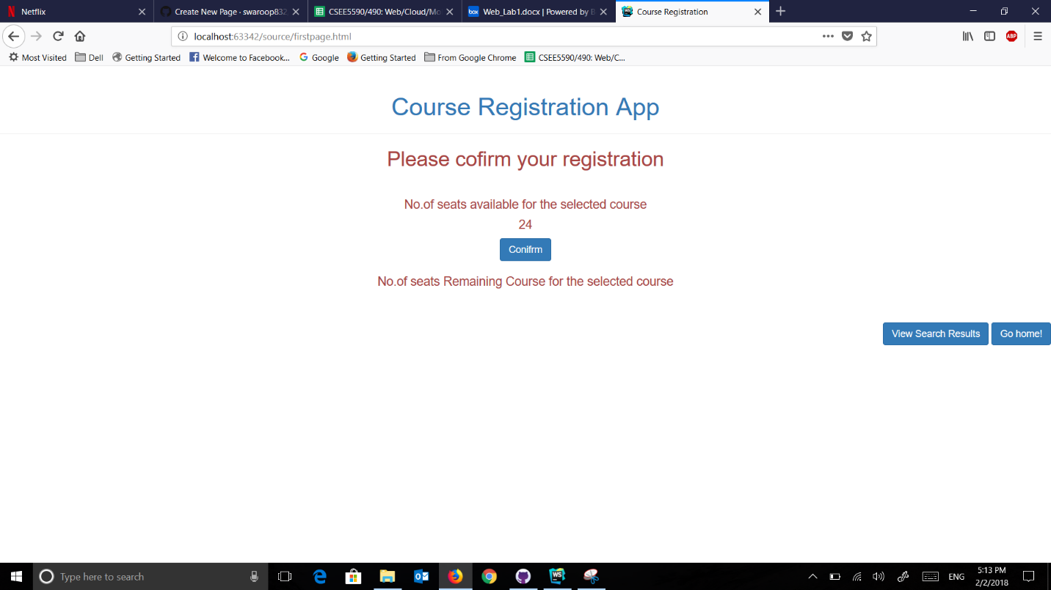

6) After Confirming the registration, it shows success message and number of seats left for that course



The number of number seats left is reflected

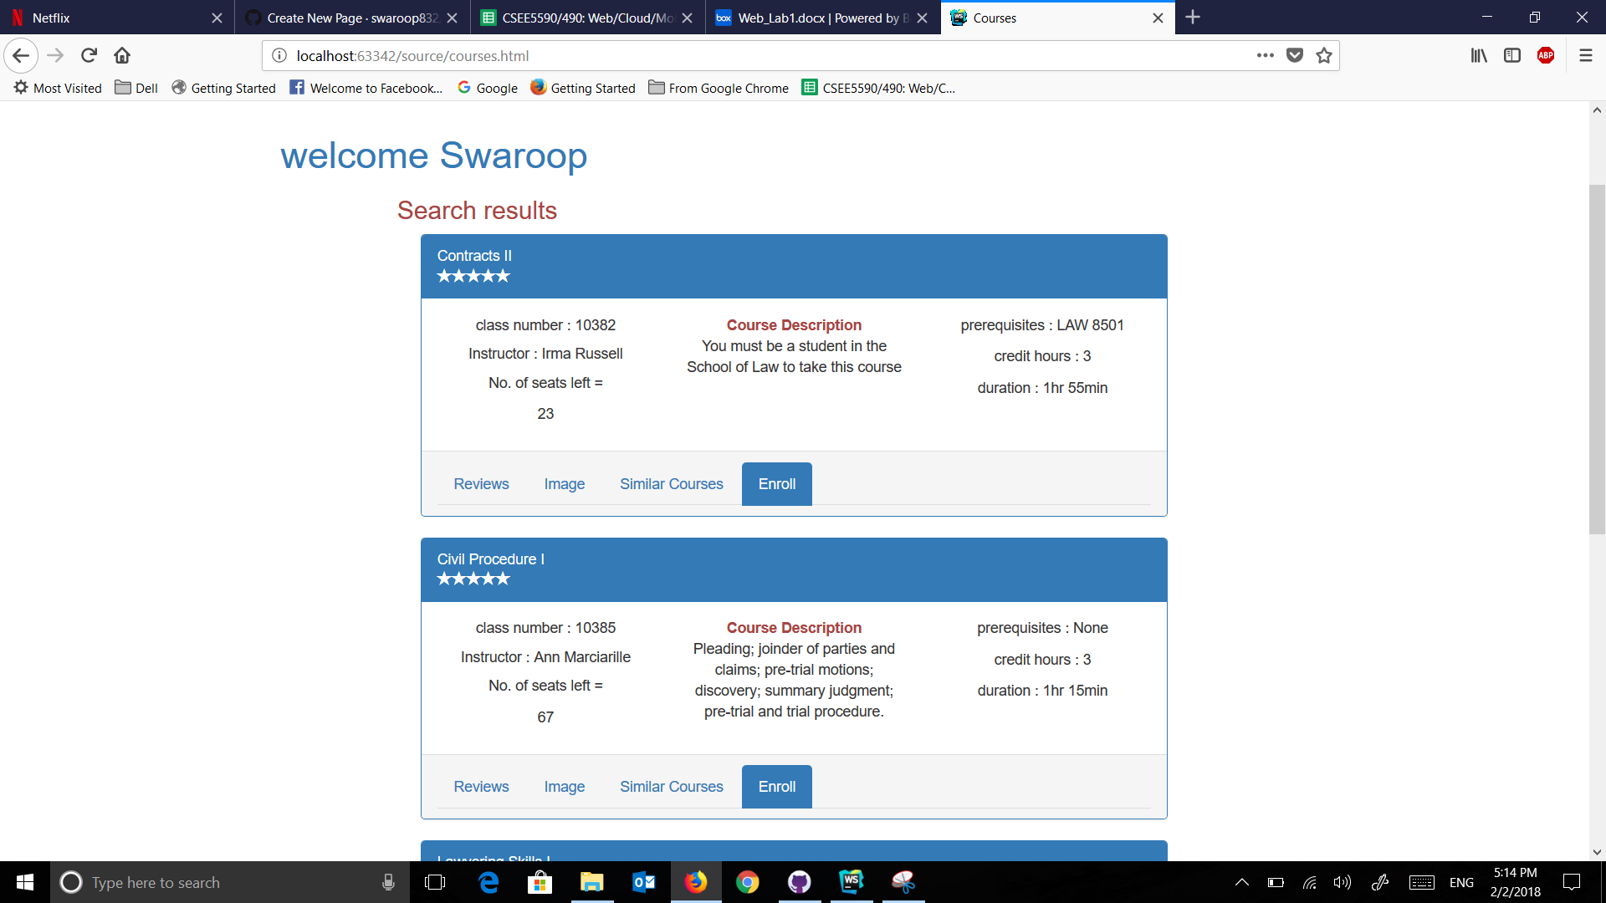

Code Snippets:

**app.js:**

**var *coursecareer1***= ***localStorage***.getItem(**"coursecareer"**);  
***console***.log(***coursecareer1***);  
**var *semester1***= ***localStorage***.getItem(**"semester"**);  
***console***.log(***semester1***);  
**var *careeroption1***= ***localStorage***.getItem(**"careeroption"**);  
***console***.log(***careeroption1***);  
**var *name1*** = ***localStorage***.getItem(**"name"**);  
***console***.log(***name1***);  
  
  
***window***.localStorage;  
**var *gfinal1***=***localStorage***.getItem(**"final1"**);  
***document***.getElementById(**"s1"**).innerText=***gfinal1***;  
**var *gfinal2*** =***localStorage***.getItem(**"final2"**);  
***document***.getElementById(**"s2"**).innerText = ***gfinal2***;  
**gfinal3** = ***localStorage***.getItem(**"final3"**);  
***document***.getElementById(**"s3"**).innerText = **gfinal3**;  
**var *gfinal4*** =***localStorage***.getItem(**"final4"**);  
***document***.getElementById(**"s4"**).innerText = ***gfinal4***;  
**var *gfinal5*** = ***localStorage***.getItem(**"final5"**);  
***document***.getElementById(**"s5"**).innerText = ***gfinal5***;  
**var *gfinal6***= ***localStorage***.getItem(**"final6"**);  
***document***.getElementById(**"s6"**).innerText = ***gfinal6***;  
**var *gfinal7*** = ***localStorage***.getItem(**"final7"**);  
***document***.getElementById(**"s7"**).innerText = ***gfinal7***;  
**var *gfinal8*** = ***localStorage***.getItem(**"final8"**);  
***document***.getElementById(**"s8"**).innerText = ***gfinal8***;  
**var *gfinal9*** = ***localStorage***.getItem(**"final9"**);  
***document***.getElementById(**"s9"**).innerText = ***gfinal9***;  
**var *gfinal10*** = ***localStorage***.getItem(**"final10"**);  
***document***.getElementById(**"s10"**).innerText = ***gfinal10***;  
**var *gfinal11*** = ***localStorage***.getItem(**"final11"**);  
***document***.getElementById(**"s11"**).innerText = ***gfinal11***;  
  
  
***localStorage***.setItem(**"s1"**,***gfinal1***);  
***localStorage***.setItem(**"s2"**,***gfinal2***);  
***localStorage***.setItem(**"s3"**,**gfinal3**);  
***localStorage***.setItem(**"s4"**,***gfinal4***);  
***localStorage***.setItem(**"s5"**,***gfinal5***);  
***localStorage***.setItem(**"s6"**,***gfinal6***);  
***localStorage***.setItem(**"s7"**,***gfinal7***);  
***localStorage***.setItem(**"s8"**,***gfinal8***);  
***localStorage***.setItem(**"s9"**,***gfinal9***);  
***localStorage***.setItem(**"s10"**,***gfinal10***);  
***localStorage***.setItem(**"s11"**,***gfinal11***);  
  
  
***document***.getElementById(**"name3"**).innerHTML = **"welcome"** + **" "** +***name1***;  
  
**if** (***coursecareer1*** === **"Under-Graduate"** && ***semester1*** === **"Spring"** && ***careeroption1*** === **"Computer Science"**) {  
  
  
 $(**'#course1'**).show(); $(**'#course2'**).show();$(**'#course3'**).show();$(**'#course4'**).hide();$(**'#course5'**).hide();$(**'#course6'**).hide();  
 $(**'#course11'**).hide();$(**'#course7'**).hide();$(**'#course8'**).hide();$(**'#course9'**).hide();$(**'#course10'**).hide();  
 ***console***.log(**"this is printed"**);  
  
} **else if**(***coursecareer1*** === **"Under-Graduate"** && ***semester1*** === **"Fall"** && ***careeroption1*** === **"Computer Science"**){  
  
 $(**'#course1'**).show(); $(**'#course2'**).show();$(**'#course3'**).show();$(**'#course4'**).show();$(**'#course5'**).hide();$(**'#course6'**).hide();  
 $(**'#course11'**).hide();$(**'#course7'**).hide();$(**'#course8'**).hide();$(**'#course9'**).hide();$(**'#course10'**).hide();  
 ***console***.log(**"this is printed3"**);  
  
  
}**else if**(***coursecareer1*** === **"Under-Graduate"** && ***semester1*** === **"Summer"** && ***careeroption1*** === **"Computer Science"**) {  
  
 $(**'#course1'**).hide(); $(**'#course2'**).hide();$(**'#course3'**).show();$(**'#course4'**).show();$(**'#course5'**).hide();$(**'#course6'**).hide();  
 $(**'#course11'**).hide();$(**'#course7'**).hide();$(**'#course8'**).hide();$(**'#course9'**).hide();$(**'#course10'**).hide();  
 ***console***.log(**"this is printed4"**);  
  
}**else if** (***coursecareer1*** === **"Under-Graduate"** && ***semester1*** === **"Spring"** && ***careeroption1*** === **"Law"**){  
  
  
 $(**'#course1'**).hide(); $(**'#course2'**).hide();$(**'#course3'**).hide();$(**'#course4'**).hide();$(**'#course5'**).hide();$(**'#course6'**).hide();  
 $(**'#course11'**).show();$(**'#course7'**).hide();$(**'#course8'**).hide();$(**'#course9'**).show();$(**'#course10'**).show();  
 ***console***.log(**"this is printed5"**);  
  
  
}**else if**(***coursecareer1*** === **"Under-Graduate"** && ***semester1*** === **"Fall"** && ***careeroption1*** === **"Law"**){  
  
 $(**'#course1'**).hide(); $(**'#course2'**).hide();$(**'#course3'**).hide();$(**'#course4'**).hide();$(**'#course5'**).hide();$(**'#course6'**).hide();  
 $(**'#course11'**).show();$(**'#course7'**).hide();$(**'#course8'**).show();$(**'#course9'**).hide();$(**'#course10'**).show();  
 ***console***.log(**"this is printed6"**);  
  
  
}**else if**(***coursecareer1*** === **"Under-Graduate"** && ***semester1*** === **"Summer"** && ***careeroption1*** === **"Law"**){  
  
 $(**'#course1'**).hide(); $(**'#course2'**).hide();$(**'#course3'**).hide();$(**'#course4'**).hide();$(**'#course5'**).hide();$(**'#course6'**).hide();  
 $(**'#course11'**).hide();$(**'#course7'**).hide();$(**'#course8'**).hide();$(**'#course9'**).hide();$(**'#course10'**).show();  
 ***console***.log(**"this is printed7"**);  
  
  
}**else if**(***coursecareer1*** === **"Graduate"** && ***semester1*** === **"Spring"** && ***careeroption1*** === **"Computer Science"**){  
  
 $(**'#course1'**).hide(); $(**'#course2'**).hide();$(**'#course3'**).show();$(**'#course4'**).show();$(**'#course5'**).show();$(**'#course6'**).show();  
 $(**'#course11'**).hide();$(**'#course7'**).hide();$(**'#course8'**).hide();$(**'#course9'**).hide();$(**'#course10'**).hide();  
 ***console***.log(**"this is printed8"**);  
  
}**else if**(***coursecareer1*** === **"Graduate"** && ***semester1*** === **"Fall"** && ***careeroption1*** === **"Computer Science"**){  
  
  
 $(**'#course1'**).hide(); $(**'#course2'**).hide();$(**'#course3'**).show();$(**'#course4'**).hide();$(**'#course5'**).show();$(**'#course6'**).show();  
 $(**'#course11'**).hide();$(**'#course7'**).show();$(**'#course8'**).hide();$(**'#course9'**).hide();$(**'#course10'**).hide();  
 ***console***.log(**"this is printed9"**);  
  
}  
**else if**(***coursecareer1*** === **"Graduate"** && ***semester1*** === **"Summer"** && ***careeroption1*** === **"Computer Science"**){  
  
 $(**'#course1'**).hide(); $(**'#course2'**).hide();$(**'#course3'**).hide();$(**'#course4'**).hide();$(**'#course5'**).hide();$(**'#course6'**).show();  
 $(**'#course11'**).hide();$(**'#course7'**).show();$(**'#course8'**).hide();$(**'#course9'**).hide();$(**'#course10'**).hide();  
 ***console***.log(**"this is printed10"**);  
  
} **else if**(***coursecareer1*** === **"Graduate"** && ***semester1*** === **"Spring"** && ***careeroption1*** === **"Law"**){  
  
 $(**'#course1'**).hide(); $(**'#course2'**).hide();$(**'#course3'**).hide();$(**'#course4'**).hide();$(**'#course5'**).hide();$(**'#course6'**).hide();  
 $(**'#course11'**).show();$(**'#course7'**).hide();$(**'#course8'**).show();$(**'#course9'**).show();$(**'#course10'**).show();  
 ***console***.log(**"this is printed11"**);  
  
}**else if**(***coursecareer1*** === **"Graduate"** && ***semester1*** === **"Fall"** && ***careeroption1*** === **"Law"**){  
  
 $(**'#course1'**).hide(); $(**'#course2'**).hide();$(**'#course3'**).hide();$(**'#course4'**).hide();$(**'#course5'**).hide();$(**'#course6'**).hide();  
 $(**'#course11'**).show();$(**'#course7'**).hide();$(**'#course8'**).show();$(**'#course9'**).show();$(**'#course10'**).show();  
 ***console***.log(**"this is printed12"**);  
  
}**else** {  
  
 $(**'#course1'**).hide(); $(**'#course2'**).hide();$(**'#course3'**).hide();$(**'#course4'**).hide();$(**'#course5'**).hide();$(**'#course6'**).hide();  
 $(**'#course11'**).show();$(**'#course7'**).hide();$(**'#course8'**).show();$(**'#course9'**).hide();$(**'#course10'**).hide();  
 ***console***.log(**"this is printed2"**);  
}  
  
  
**var *i1*** =0; **var *i2*** =0; **var *i3*** = 0; **var *i4*** =0; **var *i5*** = 0; **var *i6*** = 0; **var *i7*** = 0; **var *i8*** = 0; **var *i9*** = 0; **var *i10*** = 0 ;**var *i11*** =0;  
  
***localStorage***.setItem(**"i1"**,***i1***);  
***console***.log(***i1***);  
***localStorage***.setItem(**"i2"**,***i2***);  
***localStorage***.setItem(**"i3"**,***i3***);  
***localStorage***.setItem(**"i4"**,***i4***);  
***localStorage***.setItem(**"i5"**,***i5***);  
***localStorage***.setItem(**"i6"**,***i6***);  
***localStorage***.setItem(**"i7"**,***i7***);  
***localStorage***.setItem(**"i8"**,***i8***);  
***localStorage***.setItem(**"i9"**,***i9***);  
***localStorage***.setItem(**"i10"**,***i10***);  
***localStorage***.setItem(**"i11"**,***i11***);  
  
  
$(***document***).ready(**function** () {  
 $(**'#link1'**).each(**function** () {  
 $(**this**).click(**function** (e) {  
 ***i1***++;  
 ***console***.log(***i1***);  
 ***localStorage***.setItem(**"i1"**,***i1***);  
 });  
 });  
});  
  
$(***document***).ready(**function** () {  
 $(**'#link2'**).each(**function** () {  
 $(**this**).click(**function** (e) {  
 ***i2***++;  
 ***console***.log(***i2***);  
 ***console***.log(***i1***);  
 ***localStorage***.setItem(**"i2"**,***i2***);  
 });  
 });  
});  
$(***document***).ready(**function** () {  
 $(**'#link3'**).each(**function** () {  
 $(**this**).click(**function** (e) {  
 ***i3***++;  
 ***console***.log(***i3***);  
 ***localStorage***.setItem(**"i3"**,***i3***);  
 });  
 });  
});  
$(***document***).ready(**function** () {  
 $(**'#link4'**).each(**function** () {  
 $(**this**).click(**function** (e) {  
 ***i4***++;  
 ***console***.log(***i4***);  
 ***localStorage***.setItem(**"i4"**,***i4***);  
 });  
 });  
});  
$(***document***).ready(**function** () {  
 $(**'#link5'**).each(**function** () {  
 $(**this**).click(**function** (e) {  
 ***i5***++;  
 ***console***.log(***i5***);  
 ***localStorage***.setItem(**"i5"**,***i5***);  
 });  
 });  
});  
$(***document***).ready(**function** () {  
 $(**'#link6'**).each(**function** () {  
 $(**this**).click(**function** (e) {  
 ***i6***++;  
 ***console***.log(***i6***);  
 ***localStorage***.setItem(**"i6"**,***i6***);  
 });  
 });  
});  
  
$(***document***).ready(**function** () {  
 $(**'#link7'**).each(**function** () {  
 $(**this**).click(**function** (e) {  
 ***i7***++;  
 ***console***.log(***i7***);  
 ***localStorage***.setItem(**"i7"**,***i7***);  
 });  
 });  
});  
$(***document***).ready(**function** () {  
 $(**'#link8'**).each(**function** () {  
 $(**this**).click(**function** (e) {  
 ***i8***++;  
 ***console***.log(***i8***);  
 ***localStorage***.setItem(**"i8"**,***i8***);  
 });  
 });  
});  
$(***document***).ready(**function** () {  
 $(**'#link9'**).each(**function** () {  
 $(**this**).click(**function** (e) {  
 ***i9***++;  
 ***console***.log(***i9***);  
 ***localStorage***.setItem(**"i9"**,***i9***);  
 });  
 });  
});  
$(***document***).ready(**function** () {  
 $(**'#link10'**).each(**function** () {  
 $(**this**).click(**function** (e) {  
 ***i10***++;  
 ***console***.log(***i10***);  
 ***localStorage***.setItem(**"i10"**,***i10***);  
 });  
 });  
});  
$(***document***).ready(**function** () {  
 $(**'#link11'**).each(**function** () {  
 $(**this**).click(**function** (e) {  
 ***i11***++;  
 ***console***.log(***i11***);  
 ***localStorage***.setItem(**"i11"**,***i11***);  
 });});});  
   
**Course Registration app.js**

**var *g1*** = ***localStorage***.getItem(**"s1"**);  
**var *g2*** = ***localStorage***.getItem(**"s2"**);  
**var *g3*** = ***localStorage***.getItem(**"s3"**);  
**var *g4*** = ***localStorage***.getItem(**"s4"**);  
**var *g5*** = ***localStorage***.getItem(**"s5"**);  
**var *g6*** = ***localStorage***.getItem(**"s6"**);  
**var *g7*** = ***localStorage***.getItem(**"s7"**);  
**var *g8*** = ***localStorage***.getItem(**"s8"**);  
**var *g9*** = ***localStorage***.getItem(**"s9"**);  
**var *g10*** = ***localStorage***.getItem(**"s10"**);  
**var *g11*** = ***localStorage***.getItem(**"s11"**);  
  
**var *j1*** = *parseInt*(***localStorage***.getItem(**"i1"**));  
**var *j2*** = *parseInt*(***localStorage***.getItem(**"i2"**));  
**var *j3*** = *parseInt*(***localStorage***.getItem(**"i3"**));  
**var *j4*** = *parseInt*(***localStorage***.getItem(**"i4"**));  
**var *j5*** = *parseInt*(***localStorage***.getItem(**"i5"**));  
**var *j6*** = *parseInt*(***localStorage***.getItem(**"i6"**));  
**var *j7*** = *parseInt*(***localStorage***.getItem(**"i7"**));  
**var *j8*** = *parseInt*(***localStorage***.getItem(**"i8"**));  
**var *j9*** = *parseInt*(***localStorage***.getItem(**"i9"**));  
**var *j10*** = *parseInt*(***localStorage***.getItem(**"i10"**));  
**var *j11*** = *parseInt*(***localStorage***.getItem(**"i11"**));  
  
**if**(***j1*** !==0){  
  
***document***.getElementById(**"seatsav"**).innerText = ***g1***;  
  
}**else if**((***j2***!==0)){  
 ***document***.getElementById(**"seatsav"**).innerText = ***g2***;  
  
}**else if**(***j3***!==0){  
 ***document***.getElementById(**"seatsav"**).innerText = ***g3***;  
  
}**else if**(***j4***!==0){  
 ***document***.getElementById(**"seatsav"**).innerText = ***g4***;  
  
}**else if**(***j5***!==0){  
 ***document***.getElementById(**"seatsav"**).innerText = ***g5***;  
  
}**else if**(***j6***!==0){  
 ***document***.getElementById(**"seatsav"**).innerText = ***g6***;  
  
}**else if**(***j7***!==0){  
 ***document***.getElementById(**"seatsav"**).innerText = ***g7***;  
  
}**else if**(***j8***!==0){  
 ***document***.getElementById(**"seatsav"**).innerText = ***g8***;  
  
}**else if**(***j9***!==0){  
 ***document***.getElementById(**"seatsav"**).innerText = ***g9***;  
  
}**else if**(***j10***!==0){  
 ***document***.getElementById(**"seatsav"**).innerText = ***g10***;  
  
}**else if**(***j11***!==0){  
 ***document***.getElementById(**"seatsav"**).innerText = ***g11***;  
  
}  
  
  
**function** *confirm1*(){  
  
  
  
 **if**( (***j1***)!==0){  
  
 **if**(***g1*** === 0){  
  
 ***document***.getElementById(**"success"**).innerText= **" Registration is unsuccessful!"** + **"Seats are full"**;  
  
 }**else** {  
  
 ***document***.getElementById(**"success"**).innerText= **" Registration is successful!"**;  
 ***document***.getElementById(**"seatsRe"**).innerText = ***g1***-1;  
 ***localStorage***.setItem(**"final1"**,***g1***-1);  
 }  
  
  
 }**else if**((***j2***!==0)){  
  
 **if**(***g2***===0){  
  
 ***document***.getElementById(**"success"**).innerText= **" Registration is unsuccessful!"** + **"Seats are full"**;  
 }**else** {  
 ***document***.getElementById(**"success"**).innerText= **" Registration is successful!"**;  
 ***document***.getElementById(**"seatsRe"**).innerText = ***g2***-1;  
 ***localStorage***.setItem(**"final2"**,***g2***-1);  
  
 }  
  
  
 }**else if**(***j3***!==0){  
  
 **if**(***g3***===0){  
  
 ***document***.getElementById(**"success"**).innerText= **" Registration is unsuccessful!"** + **"Seats are full"**;  
  
 }**else** {  
  
 ***document***.getElementById(**"success"**).innerText= **" Registration is successful!"**;  
 ***document***.getElementById(**"seatsRe"**).innerText = ***g3***-1;  
 ***localStorage***.setItem(**"final3"**,***g3***-1);  
  
 }  
  
  
  
 }**else if**(***j4***!==0){  
  
 **if**(***g4***===0){  
  
 ***document***.getElementById(**"success"**).innerText= **" Registration is unsuccessful!"** + **"Seats are full"**;  
  
 }**else**{  
 ***document***.getElementById(**"success"**).innerText= **" Registration is successful!"**;  
 ***document***.getElementById(**"seatsRe"**).innerText = ***g4***-1;  
 ***localStorage***.setItem(**"final4"**,***g4***-1);  
 }  
  
  
 }**else if**(***j5***!==0){  
  
 **if**(***g5***===0){  
 ***document***.getElementById(**"success"**).innerText= **" Registration is unsuccessful!"** + **"Seats are full"**;  
  
 }**else**{  
 ***document***.getElementById(**"success"**).innerText= **" Registration is successful!"**;  
 ***document***.getElementById(**"seatsRe"**).innerText = ***g5***-1;  
 ***localStorage***.setItem(**"final5"**,***g5***-1);  
  
 }  
  
  
 }**else if**(***j6***!==0){  
  
 **if**(***g6***===0){  
  
 ***document***.getElementById(**"success"**).innerText= **" Registration is unsuccessful!"** + **"Seats are full"**;  
 }**else**{  
  
 ***document***.getElementById(**"success"**).innerText= **" Registration is successful!"**;  
 ***document***.getElementById(**"seatsRe"**).innerText = ***g6***-1;  
 ***localStorage***.setItem(**"final6"**,***g6***-1);  
 }  
  
  
 }**else if**(***j7***!==0){  
 **if**(***g7***===0){  
 ***document***.getElementById(**"success"**).innerText= **" Registration is unsuccessful!"** + **"Seats are full"**;  
  
 }**else**{  
 ***document***.getElementById(**"success"**).innerText= **" Registration is successful!"**;  
 ***document***.getElementById(**"seatsRe"**).innerText = ***g7***-1;  
 ***localStorage***.setItem(**"final7"**,***g7***-1);  
 }  
  
  
 }**else if**(***j8***!==0){  
  
 **if**(***g8***===0){  
  
 ***document***.getElementById(**"success"**).innerText= **" Registration is unsuccessful!"** + **"Seats are full"**;  
  
 }**else**{  
 ***document***.getElementById(**"success"**).innerText= **" Registration is successful!"**;  
 ***document***.getElementById(**"seatsRe"**).innerText = ***g8***-1;  
 ***localStorage***.setItem(**"final8"**,***g8***-1);  
 }  
  
  
 }**else if**(***j9***!==0){  
  
 **if**(***g9***===0){  
 ***document***.getElementById(**"success"**).innerText= **" Registration is unsuccessful!"** + **"Seats are full"**;  
  
 }**else** {  
 ***document***.getElementById(**"success"**).innerText= **" Registration is successful!"**;  
 ***document***.getElementById(**"seatsRe"**).innerText = ***g9***-1;  
 ***localStorage***.setItem(**"final9"**,***g9***-1);  
 }  
  
  
 }**else if**(***j10***!==0){  
  
 **if**(***g10***===0){  
  
 ***document***.getElementById(**"success"**).innerText= **" Registration is unsuccessful!"** + **"Seats are full"**;  
 }**else**{  
 ***document***.getElementById(**"success"**).innerText= **" Registration is successful!"**;  
 ***document***.getElementById(**"seatsRe"**).innerText = ***g10***-1;  
 ***localStorage***.setItem(**"final10"**,***g10***-1);  
  
 }  
   
 }**else if**(***j11***!==0){  
  
 **if**(***g11***===0){  
  
 ***document***.getElementById(**"success"**).innerText= **" Registration is unsuccessful!"** + **"Seats are full"**;  
 }**else**{  
  
 ***document***.getElementById(**"success"**).innerText= **" Registration is successful!"**;  
 ***document***.getElementById(**"seatsRe"**).innerText = ***g11***-1;  
 ***localStorage***.setItem(**"final11"**,***g11***-1);  
  
 }  
 }  
}

**index page**

<!DOCTYPE **html**>  
<**html lang="en"**>  
<**head**>  
 <**meta charset="UTF-8"**>  
 <**title**>Lab 1</**title**>  
 <**script src="js/angular.min.js"**></**script**>  
 <**script src="js/angular-route.min.js"**></**script**>  
 <**script src="js/jquery-3.3.1.min.js"**></**script**>  
 <**script src="https://maxcdn.bootstrapcdn.com/bootstrap/3.3.7/js/bootstrap.min.js"**></**script**>  
 <**script src="app.js"**></**script**>  
 <**link rel="stylesheet" href="css.css"**>  
 <**link rel="stylesheet" href="css/bootstrap.css"**>  
</**head**>  
<**body**>  
<**div class="container-fluid"**>  
 <**div class="page-header text-center text-primary"**><**h1**>Course Registration App</**h1**> </**div**>  
 <**div**>  
 <**div class="col-md-4"**>  
  
 </**div**>  
<**div class="col-md-4 text-center"**>  
 <**div class="form-group text-center text-primary"**>  
 <**label for="name"**>Enter Name</**label**>  
 <**input id="name" class="form-control text-center"**>  
 </**div**>  
 <**div class="form-group text-center text-primary"**>  
 <**label for="coursecareer"**>Course Career</**label**>  
 <**select id="coursecareer" class="form-control text-center" ng-value="f1"**>  
 <**option id="coursecareer1" value="Under-Graduate"**>Under-Graduate</**option**>  
 <**option value="Graduate"**>Graduate</**option**>  
 </**select**>  
 </**div**>  
 <**div class="form-group text-center text-primary"**>  
 <**label for="semester"**>Semester</**label**>  
 <**select id="semester" class="form-control text-center" ng-value="f2"**>  
 <**option value="Spring"**>Spring</**option**>  
 <**option value="Fall"**>Fall</**option**>  
 <**option value="Summer"**>Summer</**option**>  
 </**select**>  
 </**div**>  
 <**div class="form-group text-center text-primary"**>  
 <**label for="careeroption"** >Career Option</**label**>  
 <**select id="careeroption" class="form-control text-center" ng-value="f3"**>  
 <**option value="Computer Science"**>Computer Science</**option**>  
 <**option value="Law"**>Law</**option**>  
 </**select**>  
 </**div**>  
 <**button class="btn btn-primary" onclick="***onsubmit1*()**"**> Submit </**button**>  
</**div**>  
</**div**>  
</**div**>  
</**body**>  
</**html**>

**Courses Page**

<!DOCTYPE **html**>  
<**html lang="en"**>  
<**head**>  
 <**meta charset="UTF-8"**>  
 <**script src="js/angular.min.js"**></**script**>  
 <**script src="https://code.jquery.com/jquery-3.3.1.min.js"**></**script**>  
 <**script src="https://maxcdn.bootstrapcdn.com/bootstrap/3.3.7/js/bootstrap.min.js"**></**script**>  
 <**link rel="stylesheet" href="css.css"**>  
 <**link rel="stylesheet" href="css/bootstrap.css"**>  
 <**title**>Courses</**title**>  
</**head**>  
<**body**>  
<**div class="page-header text-center text-primary"**><**h1**>Course Registration App</**h1**> </**div**>  
<**br**>  
<**h1 id="name3" class="container-fluid text-primary col-lg-offset-2"**></**h1**>  
<**div**>  
 <**h3 class="text-danger col-lg-offset-3"**>Search results</**h3**>  
</**div**>  
<**div class="container-fluid"**>  
 <**div class="col-md-3"**></**div**>  
 <**div class="container-fluid col-md-6"**>  
 <**div id="courses"**>  
 <**div class="panel panel-primary" id="course1"**>  
 <**div class="panel-heading text-left"**>  
 <**div**>Problem Solving and Programming I  
 </**div**>  
 <**div**><**span class="glyphicon glyphicon-star"**></**span**><**span class="glyphicon glyphicon-star"**></**span**><**span class="glyphicon glyphicon-star"**></**span**><**span class="glyphicon glyphicon-star"**></**span**></**div**>  
 </**div**>  
 <**div class="panel-body text-center row"**>  
 <**div class="col-md-4"**>  
 <**p**> class number : 11749 </**p**>  
 <**h5**> Instructor : Kendall Bingham </**h5**>  
 <**p**> No. of seats left </**p**><**p id="s1"**>20</**p**>  
 </**div**>  
 <**div class="col-md-4"**>  
 <**b class="text-center text-danger"**> Course Description</**b**>  
 <**p**>Problem solving, algorithms and program design</**p**>  
 </**div**>  
 <**div class="col-md-4 text-center"**>  
 <**p**>prerequisites : Basic Math </**p**>  
 <**p**>credit hours : 3</**p**>  
 <**p**>duration : 1hr 15min</**p**>  
 </**div**>  
 </**div**>  
 <**div class="panel-footer"**>  
 <**ul class="nav nav-tabs"**>  
 <**li**><**a href="#review1" data-toggle="tab"**>Reviews</**a**></**li**>  
 <**li**><**a href="#image1" data-toggle="tab"**>Image</**a**></**li**>  
 <**li**><**a href="https://www.edx.org/course?search_query=problem+solving+1"**>Similar Courses</**a**></**li**>  
 <**li class="text-right"**> <**a href="firstpage.html" class="btn-primary" id="link1"**>Enroll</**a**></**li**>  
 </**ul**>  
 <**div class="tab-content"**>  
 <**div class="tab-pane fade" id="review1"**>  
 <**h4**>Reviews</**h4**>  
 <**p**> Such a great course... it has helped me so much to prepare for Graduate School.</**p**>  
 <**p**>Good course!!!!!!!!!</**p**>  
 </**div**>  
 <**div class="tab-pane fade" id="image1"**>  
 <**h4**>Image</**h4**>  
 <**img src="https://encrypted-tbn0.gstatic.com/images?q=tbn:ANd9GcS_trO6tfvGtxIKX4PHQsABqouh4_yUjZSXuwxYqmlFpO33nJ53"**>  
 </**div**>  
 </**div**>  
 </**div**>  
  
 </**div**>  
 <**div class="panel panel-primary" id="course2"**>  
 <**div class="panel-heading text-left"**>  
 <**div**>Data Structures  
 </**div**>  
 <**div**><**span class="glyphicon glyphicon-star"**></**span**><**span class="glyphicon glyphicon-star"**></**span**><**span class="glyphicon glyphicon-star"**></**span**><**span class="glyphicon glyphicon-star"**></**span**></**div**>  
 </**div**>  
 <**div class="panel-body text-center row"**>  
 <**div class="col-md-4"**>  
 <**p**> class number : 11813 </**p**>  
 <**h5**> Instructor : Brian Hare </**h5**>  
 <**p**> No. of seats left = </**p**><**p id="s2"**>12</**p**>  
 </**div**>  
 <**div class="col-md-4"**>  
 <**b class="text-center text-danger"**> Course Description</**b**>  
 <**p**>Society and Ethical Obligations of Computer Science</**p**>  
 </**div**>  
 <**div class="col-md-4 text-center"**>  
 <**p**>prerequisites : None </**p**>  
 <**p**>credit hours : 3</**p**>  
 <**p**>duration : 1hr 15min</**p**>  
 </**div**>  
 </**div**>  
 <**div class="panel-footer"**>  
 <**ul class="nav nav-tabs"**>  
 <**li**><**a href="#review2" data-toggle="tab"**>Reviews</**a**></**li**>  
 <**li**><**a href="#image2" data-toggle="tab"**>Image</**a**></**li**>  
 <**li**><**a href="https://www.edx.org/course?search_query=data+structures"**>Similar Courses</**a**></**li**>  
 <**li class="text-right"**> <**a href="firstpage.html" id="link2" class="btn-primary"**>Enroll</**a**></**li**>  
 </**ul**>  
 <**div class="tab-content"**>  
 <**div class="tab-pane fade" id="review2"**>  
 <**h4**> Reviews </**h4**>  
 <**p**>Great course, excellent material and splendid mathematical backing to all the analysis.</**p**>  
 <**p**>Great course. Very well prepared programming assignments. </**p**>  
 </**div**>  
 <**div class="tab-pane fade" id="image2"**>  
 <**h4**>Image</**h4**>  
 <**img src="https://encrypted-tbn0.gstatic.com/images?q=tbn:ANd9GcTaKE6NnEPbkbVWgZpb7Oy5Fz65CJs7v2K5P55gagoD7mPAFbZA"**>  
 </**div**>  
 </**div**>  
  
 </**div**>  
  
 </**div**>  
 <**div class="panel panel-primary" id="course3"**>  
 <**div class="panel-heading text-left"**>  
 <**div**>Introduction to Statistical Learning  
 </**div**>  
 <**div**><**span class="glyphicon glyphicon-star"**></**span**><**span class="glyphicon glyphicon-star"**></**span**><**span class="glyphicon glyphicon-star"**></**span**></**div**>  
 </**div**>  
 <**div class="panel-body text-center row"**>  
 <**div class="col-md-4"**>  
 <**p**> class number : 16706 </**p**>  
 <**h5**> Instructor : Kenneth Mitchell </**h5**>  
 <**p**> No. of seats left</**p**><**p id="s3"**>53</**p**>  
 </**div**>  
 <**div class="col-md-4"**>  
 <**b class="text-center text-danger"**> Course Description</**b**>  
 <**p**>Pratical introduction to analytical technics used in computer science</**p**>  
 </**div**>  
 <**div class="col-md-4 text-center"**>  
 <**p**>prerequisites : None </**p**>  
 <**p**>credit hours : 3</**p**>  
 <**p**>duration : 1hr 15min</**p**>  
 </**div**>  
 </**div**>  
 <**div class="panel-footer"**>  
 <**ul class="nav nav-tabs"**>  
 <**li**><**a href="#review3" data-toggle="tab"**>Reviews</**a**></**li**>  
 <**li**><**a href="#image3" data-toggle="tab"**>Image</**a**></**li**>  
 <**li**><**a href="https://www.coursera.org/courses?languages=en&query=statistical+learning"**>Simialar Courses</**a**></**li**>  
 <**li class="text-right"**> <**a href="firstpage.html" id="link3" class="btn-primary"**>Enroll</**a**></**li**>  
 </**ul**>  
 <**div class="tab-content"**>  
 <**div class="tab-pane fade" id="review3"**>  
 <**h4**> Reviews </**h4**>  
 <**p**>This is very engaging and informative course. I specially like the way instructors clarify the ideas . Their occasional jokes make this course more enjoyable. Besides that, there are some insightful interviews and watching them was quite inspiring. </**p**>  
 <**p**>Excellent course with amazing instructors.</**p**>  
 </**div**>  
 <**div class="tab-pane fade" id="image3"**>  
 <**h4**>Image</**h4**>  
 <**img src="https://encrypted-tbn0.gstatic.com/images?q=tbn:ANd9GcSpzzyQ5HuADYWVVqBxYt8W0I2S6rVUerP73TlIjXvdJYgc0MDK"**>  
 </**div**>  
 </**div**>  
  
 </**div**>  
  
 </**div**>  
 <**div class="panel panel-primary" id="course4"**>  
 <**div class="panel-heading text-left"**>  
 <**div**>Software Architecture: Testing & Maintenance  
 </**div**>  
 <**div**><**span class="glyphicon glyphicon-star"**></**span**><**span class="glyphicon glyphicon-star"**></**span**><**span class="glyphicon glyphicon-star"**></**span**><**span class="glyphicon glyphicon-star"**></**span**><**span class="glyphicon glyphicon-star"**></**span**></**div**>  
 </**div**>  
 <**div class="panel-body text-center row"**>  
 <**div class="col-md-4"**>  
 <**p**> class number : 14187 </**p**>  
 <**h5**> Instructor : Yijie Han </**h5**>  
 <**p**> No. of seats left = </**p**><**p id="s4"**>5</**p**>  
 </**div**>  
 <**div class="col-md-4"**>  
 <**b class="text-center text-danger"**> Course Description</**b**>  
 <**p**>Software testing, Software Process, Software Reuse</**p**>  
 </**div**>  
 <**div class="col-md-4 text-center"**>  
 <**p**>prerequisites : None </**p**>  
 <**p**>credit hours : 3</**p**>  
 <**p**>duration : 1hr 15min</**p**>  
 </**div**>  
 </**div**>  
 <**div class="panel-footer"**>  
 <**ul class="nav nav-tabs"**>  
 <**li**><**a href="#review4" data-toggle="tab"**>Reviews</**a**></**li**>  
 <**li**><**a href="#image4" data-toggle="tab"**>Image</**a**></**li**>  
 <**li**><**a href="https://www.coursera.org/courses?languages=en&query=software+design+and+architecture"**>Similar Courses</**a**></**li**>  
 <**li class="text-right"**> <**a href="firstpage.html" id="link4" class="btn-primary"**>Enroll</**a**></**li**>  
 </**ul**>  
 <**div class="tab-content"**>  
 <**div class="tab-pane fade" id="review4"**>  
 <**h4**> Review </**h4**>  
 <**p**>Excellent course with amazing instructors.</**p**>  
 </**div**>  
 <**div class="tab-pane fade" id="image4"**>  
 <**h4**>Image</**h4**>  
 <**img src="https://encrypted-tbn0.gstatic.com/images?q=tbn:ANd9GcS73VwBzI5AEvQmINamvqAq2SU2sotuO0HBokwkqnqe7AN7B4fe"**>  
 </**div**>  
 </**div**>  
 </**div**>  
 </**div**>  
 <**div class="panel panel-primary" id="course5"**>  
 <**div class="panel-heading text-left"**>  
 <**div**>Software Architecture and Design  
 </**div**>  
 <**div**><**span class="glyphicon glyphicon-star"**></**span**><**span class="glyphicon glyphicon-star"**></**span**><**span class="glyphicon glyphicon-star"**></**span**><**span class="glyphicon glyphicon-star"**></**span**><**span class="glyphicon glyphicon-star"**></**span**></**div**>  
 </**div**>  
 <**div class="panel-body text-center row"**>  
 <**div class="col-md-4"**>  
 <**p**> class number : 14993 </**p**>  
 <**h5**> Instructor : Yongjie Zheng </**h5**>  
 <**p**> No. of seats left</**p**><**p id="s5"**>26</**p**>  
 </**div**>  
 <**div class="col-md-4"**>  
 <**b class="text-center text-danger"**> Course Description</**b**>  
 <**p**>The course introduces a number of basic concepts and enabling technologies of software architecture</**p**>  
 </**div**>  
 <**div class="col-md-4 text-center"**>  
 <**p**>prerequisites : CS451R </**p**>  
 <**p**>credit hours : 3</**p**>  
 <**p**>duration : 1hr 15min</**p**>  
 </**div**>  
 </**div**>  
 <**div class="panel-footer"**>  
 <**ul class="nav nav-tabs"**>  
 <**li**><**a href="#review5" data-toggle="tab"**>Reviews</**a**></**li**>  
 <**li**><**a href="#image5" data-toggle="tab"**>Image</**a**></**li**>  
 <**li**><**a href="https://www.coursera.org/courses?languages=en&query=software+design+and+architecture"**>Similar Courses</**a**></**li**>  
 <**li class="text-right"**> <**a href="firstpage.html" id="link5" class="btn-primary"**>Enroll</**a**></**li**>  
 </**ul**>  
 <**div class="tab-content"**>  
 <**div class="tab-pane fade" id="review5"**>  
 <**h4**> Review </**h4**>  
 <**p**>Good Course!</**p**>  
 </**div**>  
 <**div class="tab-pane fade" id="image5"**>  
 <**h4**>Image</**h4**>  
 <**img src="https://encrypted-tbn0.gstatic.com/images?q=tbn:ANd9GcS73VwBzI5AEvQmINamvqAq2SU2sotuO0HBokwkqnqe7AN7B4fe"**>  
 </**div**>  
 </**div**>  
  
 </**div**>  
  
 </**div**>  
 <**div class="panel panel-primary" id="course6"**>  
 <**div class="panel-heading text-left"**>  
 <**div**>Cloud Computing  
 </**div**>  
 <**div**><**span class="glyphicon glyphicon-star"**></**span**><**span class="glyphicon glyphicon-star"**></**span**><**span class="glyphicon glyphicon-star"**></**span**><**span class="glyphicon glyphicon-star"**></**span**><**span class="glyphicon glyphicon-star"**></**span**></**div**>  
 </**div**>  
 <**div class="panel-body text-center row"**>  
 <**div class="col-md-4"**>  
 <**p**> class number : 17176 </**p**>  
 <**h5**> Instructor : Baek-Young Choi </**h5**>  
 <**p**> No. of seats left</**p**><**p id="s6"**>2</**p**>  
 </**div**>  
 <**div class="col-md-4"**>  
 <**b class="text-center text-danger"**> Course Description</**b**>  
 <**p**>Cloud computing systems operate in a very large scale, and are impacting the economics.</**p**>  
 </**div**>  
 <**div class="col-md-4 text-center"**>  
 <**p**>prerequisites : CSEE 5110 </**p**>  
 <**p**>credit hours : 3</**p**>  
 <**p**>duration : 1hr 15min</**p**>  
 </**div**>  
 </**div**>  
 <**div class="panel-footer"**>  
 <**ul class="nav nav-tabs"**>  
 <**li**><**a href="#review6" data-toggle="tab"**>Reviews</**a**></**li**>  
 <**li**><**a href="#image6" data-toggle="tab"**>Image</**a**></**li**>  
 <**li**><**a href="https://www.coursera.org/courses?languages=en&query=cloud+computing"**>Similar Courses</**a**></**li**>  
 <**li class="text-right"**> <**a href="firstpage.html" id="link6" class="btn-primary"**>Enroll</**a**></**li**>  
 </**ul**>  
 <**div class="tab-content"**>  
 <**div class="tab-pane fade" id="review6"**>  
 <**h4**> Review </**h4**>  
 <**p**>Some lessons seemed to be going too much into details whereas others not enough details.</**p**>  
 </**div**>  
 <**div class="tab-pane fade" id="image6"**>  
 <**h4**>Image</**h4**>  
 <**img src="https://encrypted-tbn0.gstatic.com/images?q=tbn:ANd9GcSgOtj-73tYJfchbUVw5A90CuGqNmzJcIW2ASiFuZzVBUhlyz8Q"**>  
 </**div**>  
 </**div**>  
 </**div**>  
  
 </**div**>  
 <**div class="panel panel-primary" id="course7"**>  
 <**div class="panel-heading text-left"**>  
 <**div**>Design and Analysis of Algorithms  
 </**div**>  
 <**div**><**span class="glyphicon glyphicon-star"**></**span**><**span class="glyphicon glyphicon-star"**></**span**><**span class="glyphicon glyphicon-star"**></**span**><**span class="glyphicon glyphicon-star"**></**span**><**span class="glyphicon glyphicon-star"**></**span**></**div**>  
 </**div**>  
 <**div class="panel-body text-center row"**>  
 <**div class="col-md-4"**>  
 <**p**> class number : 14992 </**p**>  
 <**h5**> Instructor : Appie Van De Liefvoort </**h5**>  
 <**p**> No. of seats left =</**p**><**p id="s7"**>32 </**p**>  
 </**div**>  
 <**div class="col-md-4"**>  
 <**b class="text-center text-danger"**> Course Description</**b**>  
 <**p**>Combinatorial analysis, searching and sorting, shortest path algorithms</**p**>  
 </**div**>  
 <**div class="col-md-4 text-center"**>  
 <**p**>prerequisites : COMP-SCI 303 </**p**>  
 <**p**>credit hours : 3</**p**>  
 <**p**>duration : 1hr 15min</**p**>  
 </**div**>  
 </**div**>  
 <**div class="panel-footer"**>  
 <**ul class="nav nav-tabs"**>  
 <**li**><**a href="#review7" data-toggle="tab"**>Reviews</**a**></**li**>  
 <**li**><**a href="#image7" data-toggle="tab"**>Image</**a**></**li**>  
 <**li**><**a href="https://www.coursera.org/courses?languages=en&query=algorithm+design+and+analysis"**>Similar Courses</**a**></**li**>  
 <**li class="text-right"**> <**a href="firstpage.html" id ="link7" class="btn-primary"**>Enroll</**a**></**li**>  
 </**ul**>  
 <**div class="tab-content"**>  
 <**div class="tab-pane fade" id="review7"**>  
 <**h4**> Reviews </**h4**>  
 <**p**>This was going to be a review of material for me, just a refresher. But instead I was exposed to a lot of new concepts and really feel like I got some good experience from it.</**p**>  
 </**div**>  
 <**div class="tab-pane fade" id="image7"**>  
 <**h4**>Image</**h4**>  
 <**img src="https://encrypted-tbn0.gstatic.com/images?q=tbn:ANd9GcQRxppOI-DXD1ecDtBF6B5NAsIom0yh2iIQFUewSzpMRpTbFr6d"**>  
 </**div**>  
 </**div**>  
 </**div**>  
 </**div**>  
 <**div class="panel panel-primary" id="course8"**>  
 <**div class="panel-heading text-left"**>  
 <**div**>Contracts II  
 </**div**>  
 <**div**><**span class="glyphicon glyphicon-star"**></**span**><**span class="glyphicon glyphicon-star"**></**span**><**span class="glyphicon glyphicon-star"**></**span**><**span class="glyphicon glyphicon-star"**></**span**><**span class="glyphicon glyphicon-star"**></**span**></**div**>  
 </**div**>  
 <**div class="panel-body text-center row"**>  
 <**div class="col-md-4"**>  
 <**p**> class number : 10382 </**p**>  
 <**h5**> Instructor : Irma Russell </**h5**>  
 <**p**> No. of seats left =</**p**><**p id="s8"**> 43</**p**>  
 </**div**>  
 <**div class="col-md-4"**>  
 <**b class="text-center text-danger"**> Course Description</**b**>  
 <**p**>You must be a student in the School of Law to take this course</**p**>  
 </**div**>  
 <**div class="col-md-4 text-center"**>  
 <**p**>prerequisites : LAW 8501 </**p**>  
 <**p**>credit hours : 3</**p**>  
 <**p**>duration : 1hr 55min</**p**>  
 </**div**>  
 </**div**>  
 <**div class="panel-footer"**>  
 <**ul class="nav nav-tabs"**>  
 <**li**><**a href="#review8" data-toggle="tab"**>Reviews</**a**></**li**>  
 <**li**><**a href="#image8" data-toggle="tab"**>Image</**a**></**li**>  
 <**li**><**a href="https://www.edx.org/course/contract-law-from-trust-to-promise-to-contract"**>Similar Courses</**a**></**li**>  
 <**li class="text-right"**> <**a href="firstpage.html" id = "link8" class="btn-primary"**>Enroll</**a**></**li**>  
 </**ul**>  
 <**div class="tab-content"**>  
 <**div class="tab-pane fade" id="review8"**>  
 <**h4**> Reviews </**h4**>  
 <**p**>All concepts are presented in a very understandable way and are supported by precedents.</**p**>  
 </**div**>  
 <**div class="tab-pane fade" id="image8"**>  
 <**h4**>Image</**h4**>  
 <**img src="https://encrypted-tbn0.gstatic.com/images?q=tbn:ANd9GcTieqwfUWBG1qvb-n9hgij4mBlZYzuBfa9Tu8kGAya5eOwKTAnx"**>  
 </**div**>  
 </**div**>  
 </**div**>  
 </**div**>  
 <**div class="panel panel-primary" id="course9"**>  
 <**div class="panel-heading text-left"**>  
 <**div**>Civil Procedure I  
 </**div**>  
 <**div**><**span class="glyphicon glyphicon-star"**></**span**><**span class="glyphicon glyphicon-star"**></**span**><**span class="glyphicon glyphicon-star"**></**span**><**span class="glyphicon glyphicon-star"**></**span**><**span class="glyphicon glyphicon-star"**></**span**></**div**>  
 </**div**>  
 <**div class="panel-body text-center row"**>  
 <**div class="col-md-4"**>  
 <**p**> class number : 10385 </**p**>  
 <**h5**> Instructor : Ann Marciarille </**h5**>  
 <**p**> No. of seats left = </**p**><**p id="s9"**>42</**p**>  
 </**div**>  
 <**div class="col-md-4"**>  
 <**b class="text-center text-danger"**> Course Description</**b**>  
 <**p**>Pleading; joinder of parties and claims; pre-trial motions; discovery; summary judgment; pre-trial and trial procedure.</**p**>  
 </**div**>  
 <**div class="col-md-4 text-center"**>  
 <**p**>prerequisites : None </**p**>  
 <**p**>credit hours : 3</**p**>  
 <**p**>duration : 1hr 15min</**p**>  
 </**div**>  
 </**div**>  
 <**div class="panel-footer"**>  
 <**ul class="nav nav-tabs"**>  
 <**li**><**a href="#review9" data-toggle="tab"**>Reviews</**a**></**li**>  
 <**li**><**a href="#image9" data-toggle="tab"**>Image</**a**></**li**>  
 <**li**><**a href="https://www.edx.org/course/subject/law"**>Similar Courses</**a**></**li**>  
 <**li class="text-right"**> <**a href="firstpage.html" id="link9" class="btn-primary"**>Enroll</**a**></**li**>  
 </**ul**>  
 <**div class="tab-content"**>  
 <**div class="tab-pane fade" id="review9"**>  
 <**h4**> Reviews </**h4**>  
 <**p**>Thorough and comprehensive.</**p**>  
 <**p**>Great supplement to help me better understand Civ Pro which is by far my least favorite 1L class.</**p**>  
 </**div**>  
 <**div class="tab-pane fade" id="image9"**>  
 <**h4**>Image</**h4**>  
 <**img src="https://images-na.ssl-images-amazon.com/images/I/51dDLc2BmoL._SX345_BO1,204,203,200_.jpg"**>  
 </**div**>  
 </**div**>  
 </**div**>  
 </**div**>  
 <**div class="panel panel-primary" id="course10"**>  
 <**div class="panel-heading text-left"**>  
 <**div**>Lawyering Skills I  
 </**div**>  
 <**div**><**span class="glyphicon glyphicon-star"**></**span**><**span class="glyphicon glyphicon-star"**></**span**><**span class="glyphicon glyphicon-star"**></**span**><**span class="glyphicon glyphicon-star"**></**span**><**span class="glyphicon glyphicon-star"**></**span**></**div**>  
 </**div**>  
 <**div class="panel-body text-center row"**>  
 <**div class="col-md-4"**>  
 <**p**> class number : 17188</**p**>  
 <**h5**> Instructor : Thomas Nanney </**h5**>  
 <**p**> No. of seats left = </**p**><**p id="s10"**>6</**p**>  
 </**div**>  
 <**div class="col-md-4"**>  
 <**b class="text-center text-danger"**> Course Description</**b**>  
 <**p**>Introduction to legal reasoning; case analysis and synthesis; case research.</**p**>  
 </**div**>  
 <**div class="col-md-4 text-center"**>  
 <**p**>prerequisites : None </**p**>  
 <**p**>credit hours : 3</**p**>  
 <**p**>duration : 1hr 15min</**p**>  
 </**div**>  
 </**div**>  
 <**div class="panel-footer"**>  
 <**ul class="nav nav-tabs"**>  
 <**li**><**a href="#review10" data-toggle="tab"**>Reviews</**a**></**li**>  
 <**li**><**a href="#image10" data-toggle="tab"**>Image</**a**></**li**>  
 <**li**><**a href="https://www.edx.org/course/subject/law"**>Similar Courses</**a**></**li**>  
 <**li class="text-right"**> <**a href="firstpage.html" id="link10" class="btn-primary"**>Enroll</**a**></**li**>  
 </**ul**>  
 <**div class="tab-content"**>  
 <**div class="tab-pane fade" id="review10"**>  
 <**h4**> Reviews </**h4**>  
 <**p**>Good Course!</**p**>  
 </**div**>  
 <**div class="tab-pane fade" id="image10"**>  
 <**h4**>Image</**h4**>  
 <**img src="https://encrypted-tbn0.gstatic.com/images?q=tbn:ANd9GcRIZWCVkIzRGWRrdyC5KK1DAJiXH1dImImUj7h31ckyTySXCEZD"**>  
 </**div**>  
 </**div**>  
 </**div**>  
 </**div**>  
 <**div class="panel panel-primary" id="course11"**>  
 <**div class="panel-heading text-left"**>  
 <**div**>Common Law, Legal Analysis & Writing  
 </**div**>  
 <**div**><**span class="glyphicon glyphicon-star"**></**span**><**span class="glyphicon glyphicon-star"**></**span**><**span class="glyphicon glyphicon-star"**></**span**><**span class="glyphicon glyphicon-star"**></**span**><**span class="glyphicon glyphicon-star"**></**span**></**div**>  
 </**div**>  
 <**div class="panel-body text-center row"**>  
 <**div class="col-md-4"**>  
 <**p**> class number : 15070 </**p**>  
 <**h5**> Instructor : Thomas Nanney </**h5**>  
 <**p**> No. of seats left</**p**><**p id="s11"**>12</**p**>  
 </**div**>  
 <**div class="col-md-4"**>  
 <**b class="text-center text-danger"**> Course Description</**b**>  
 <**p**>Introduction to legal reasoning; case analysis and synthesis; case research.</**p**>  
 </**div**>  
 <**div class="col-md-4 text-center"**>  
 <**p**>prerequisites : None </**p**>  
 <**p**>credit hours : 3</**p**>  
 <**p**>duration : 1hr 15min</**p**>  
 </**div**>  
 </**div**>  
 <**div class="panel-footer"**>  
 <**ul class="nav nav-tabs"**>  
 <**li**><**a href="#review11" data-toggle="tab"**>Reviews</**a**></**li**>  
 <**li**><**a href="#image11" data-toggle="tab"**>Image</**a**></**li**>  
 <**li**><**a href="https://www.edx.org/course/subject/law"**>Similar Courses</**a**></**li**>  
 <**li class="text-right"**> <**a href="firstpage.html" id="link11" class="btn-primary"**>Enroll</**a**></**li**>  
 </**ul**>  
 <**div class="tab-content"**>  
 <**div class="tab-pane fade" id="review11"**>  
 <**h4**> Review </**h4**>  
 <**p**>Good Course!</**p**>  
 </**div**>  
 <**div class="tab-pane fade" id="image11"**>  
 <**h4**>Image</**h4**>  
 <**img src="https://encrypted-tbn0.gstatic.com/images?q=tbn:ANd9GcRIZWCVkIzRGWRrdyC5KK1DAJiXH1dImImUj7h31ckyTySXCEZD"**>  
 </**div**>  
 </**div**>  
 </**div**>  
 </**div**>  
 </**div**>  
 </**div**>  
</**div**>  
<**div class="text-center"**>  
 <**a class="btn btn-primary" href="index.html"**>Go back</**a**>  
  
</**div**>  
  
<**script src="app1.js"**></**script**>  
  
</**body**>  
</**html**>

**Course Registration Page**

<!DOCTYPE **html**>  
<**html lang="en"**>  
<**head**>  
 <**meta charset="UTF-8"**>  
 <**title**>Course Registration</**title**>  
 <**script src="js/jquery-3.3.1.min.js"**></**script**>  
 <**script src="js/bootstrap.js"**></**script**>  
 <**link rel="stylesheet" href="css/bootstrap.min.css"**>  
  
</**head**>  
<**body**>  
<**div class="page-header text-center text-primary"**><**h1**>Course Registration App</**h1**> </**div**>  
<**div class="text-center"**>  
 <**h2 class="text-danger"**>Please cofirm your registration</**h2**>  
  
</**div**>  
<**br**>  
<**div class="text-danger text-center"**><**h4**>No.of seats available for the selected course</**h4**>  
 <**h4 id="seatsav" class="text-center"**></**h4**></**div**>  
  
<**div class="text-center"**>  
 <**button class="btn btn-primary" id="confirm" onclick="***confirm1*()**"**>Conifrm</**button**>  
</**div**>  
<**h3 class="text-success text-center" id="success"**></**h3**>  
<**div class="text-danger text-center"**><**h4**>No.of seats Remaining Course for the selected course</**h4**>  
 <**h4 id="seatsRe" class="text-center"**></**h4**></**div**>  
<**br**>  
<**br**>  
<**div class="text-right col-md-offset-3"**>  
 <**a class="btn btn-primary" href="courses.html"**>View Search Results</**a**>  
 <**a class="btn btn-primary" href="index.html"**>Go home!</**a**>  
</**div**>  
  
  
  
<**script src="appfirst.js"**></**script**>  
</**body**>  
</**html**>